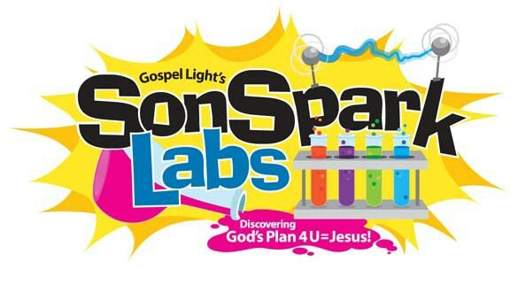
Monday August 3rd-Friday August 7th, 9:00 A.M. to 12:00 P.M. Join us for SonSpark Labs Vacation Bible School at Trinity United Methodist Church at 180 Park Ave. Experience a week of laboratory adventures and fun! We will have a great time with lively songs, hilarious skits, creative crafts, exciting games, Bible stories and tasty snacks. Cost for the week is only 7$ per child, 5$ per child if registered before July 5th. To Register Call 860 688-9245 or online at www.tumcwindsor.org.

